Sixth Grade Science 6
Unit 5 study guide
- 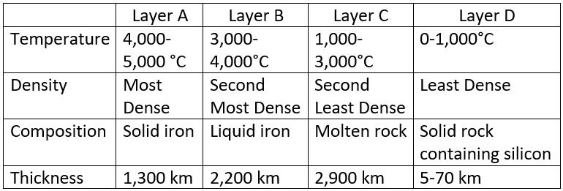
Based on the information in the table, which layer is most likely the (a) Crust, (b) Mantle, (c) Outer Core, (d) Inner Core?
a.
b.
c.
d.

2. Which list is the correct order of the Earth layers from outermost to innermost?
A. Outer Core, Mantle, Inner Core, Crust
B. Crust, Mantle, Outer Core, Inner Core
C. Inner Core, Outer Core, Mantle, Crust
D. Mantle, Outer Core, Inner Core, Crust

