DIRECTIONS: Look at the pictures and answer the questions.
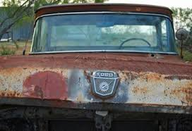
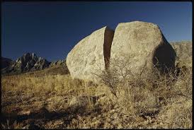
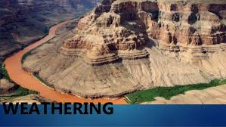

- Describe what you see in each of the pictures.

- Write two questions that you have about what you see in the pictures.

